Jmeter Sample:- S00_T01_LoadURL is with Generate parent sample checked. There are 3 HTTP requests within it (1,5,6)

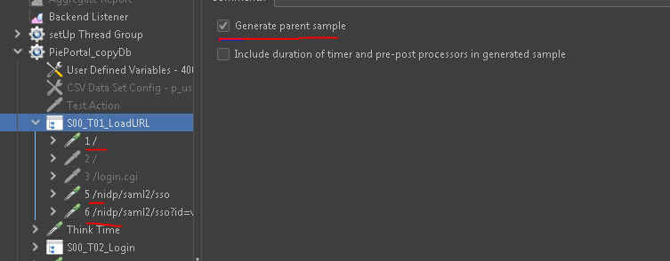

Snapshot from Jenkins Performance Report:- Contains both main transaction and child HTTP Requests which is not the case with earlier versions of JMETER

